

- Control, Efficiency, Visibility



__________________________________________

User Manual

SOLAS Requirement

VGM Submission

To Carriers via INTTRA

**__________________________________________**

Table of Contents

1. How to Send VGM EDI Transactions to Carriers 3

Accessing the VGM Function 3

Selecting the Submission Type 3

Entering the Required Parties 5

Entering the Required Fields 5

Entering Carrier notification email address 6

Submitting the Container VGM record to the Carrier 7

# How to Send VGM EDI Transactions to Carriers

The VGM EDI function in Logiware will allow you to send EDI messages through INTTRA to the Carriers of Verified Gross Mass for each container. This is in compliance of the SOLAS regulation that will go into effect on July 1, 2016.

Note: This function will work for Carriers that are part of the INTTRA network.

## Accessing the VGM Function

The VGM function can be accessed from the Bill of Lading Screen by clicking on the button as shown below:

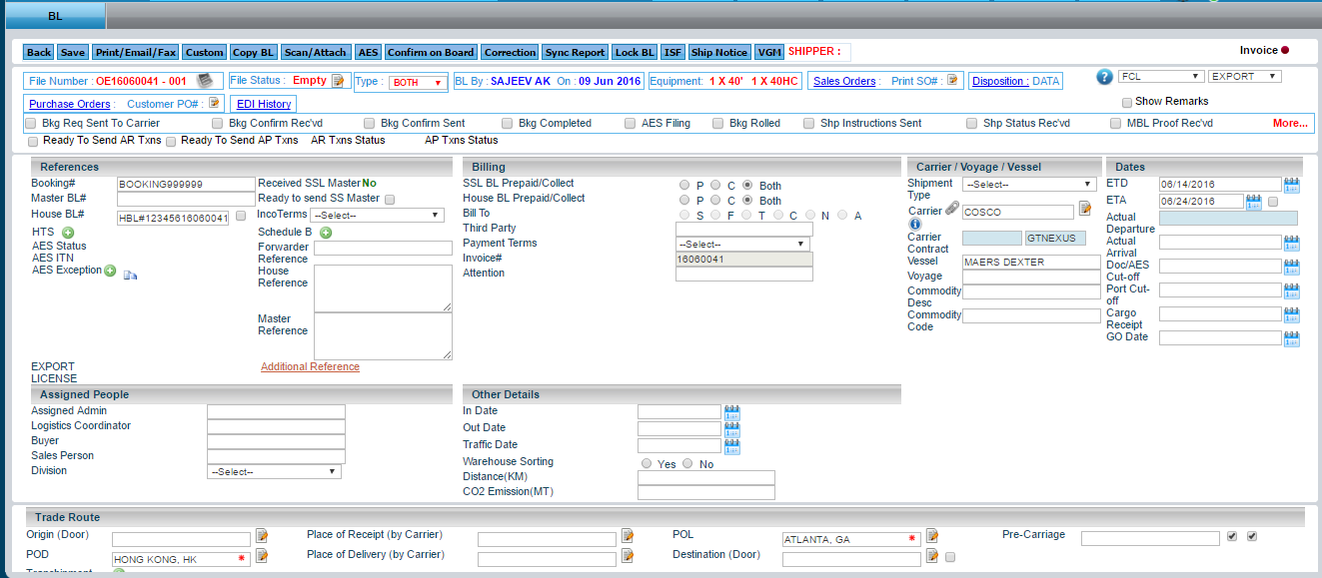

The VGM Panel will then be displayed:

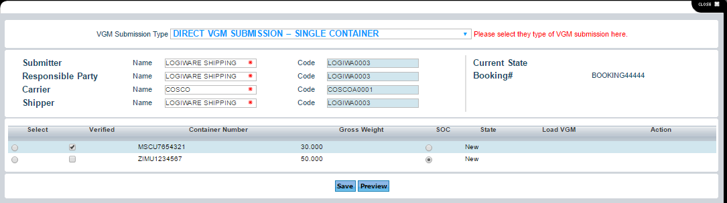

## Selecting the Submission Type

① The first step in the VGM process is to select the Method for submitting the VGM. The choices will be listed by clicking on the VGM SUBMISSION TYPE list box:

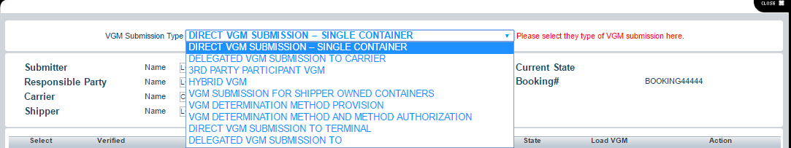

The Method choices are listed below:

* **1) Direct VGM Submission** – the Responsible Party signs and submits VGM to the Carrier. Authorized Party will not be provided. A typical scenario is one in which the Beneficial Cargo Owner (BCO) is the Shipper and the BCO is providing VGM details directly to the Carrier. Variations include Forwarder or NVO acting as Shipper for their bookings with Vessel Operator Carriers. The Shipper is expected to be the Submitter. Typically, one of Shipper or Forwarder and Carrier will be provided along with the Responsible Party. Signature will be provided under the Responsible Party. The transaction may also include the VGM Determination details.
* **2) Delegated VGM Submission to Carrier** – the Authorized Party signs and submits VGM to the Carrier. The Responsible Party has delegated VGM signature authority to an Authorized party. Typical scenario is that a Forwarder is filing VGM for a Shipper. The Shipper is the Responsible Party and the Forwarder is the Authorized party. The Forwarder is expected to be the Submitter. This transaction may also include VGM Determination details.
* **3) 3rd Party Participant VGM** – the 3rd Party submits VGM to Responsible Party or Authorized Party. Typical scenario is that a Scale is sending weights to a Shipper or a Forwarder (3PL). The Recipients will 'sign' the VGM for delivery to the Carrier. A variant has a Terminal weighing the container. The weights are VGM's, but not signed and are being routed to the party that will sign them. In this case, one of the two Methods (Method1 or Method2) will be provided. The Weighing Party will be reported. The Weigher is the Submitter. In this use case, Verification Details (Signature & Date) will not be provided. It is also likely that the Responsible Party will not be provided as the Weigher can be sending the transaction to a 3PL. Hybrid VGM – The Shipper ordered the weighing at the Weighing facility
* **4) Hybrid VGM** – 3rd Party submits VGM to the Carrier and the Responsible Party. Typical scenario is that a Terminal is weighing an incoming container. The Shipper has authorized the Terminal to sign VGMs on the Shipper's behalf. In this case, the Shipper is the Responsible Party, the Terminal is the Submitter, the Authorized party and the Weighing Party. Carrier and Shipper (BCO, NVO, Co-loading Forwarder) will be provided. Signature will be provided for the Authorized party (with Delegated flag set to ‘true’). In this case, one of the two Methods (Method1 or Method2) will be provided. The Weighing Party will be reported.
* **5) VGM Submission for Shipper Owned Containers** - the Responsible Party signs and submits VGM for a shipper owned container to the Carrier. By default, INTTRA assumes that containers are supplied by Carriers. In this case, the Shipper Supplied flag should be set and the ISO type should be provided. Otherwise the transaction is typical.
* **6) VGM Determination Method Provision** – the Responsible Party signs and submits VGM along with its determination method to the Carrier. It is expected that some jurisdictions will require that the method of determination be reported as part of VGM submission. This requirement would apply regardless of who submits the VGM for official consumption (Carrier, Terminal). Method reporting requires that details related to Determination Method be provided.
* **7) VGM Determination Method and Method Authorization** – the Responsible Party signs and submits VGM to Carrier along with its determination method and also includes the method Authorization Number. It is expected that some jurisdictions will require Weighers to be authorized to use specific determination methods. Evidence of Authorization (Authorization Number) will be required as part of VGM submission. This requirement applies to the Weighing Party. For example, it seems that the UK will require Method 2 weighers to be authorized and that the Authorization Number has to be included with the Method 2 VGM submissions.
* **8) Direct VGM Submission to Terminal** – the Responsible Party signs and submits VGM to the Terminal. Generally it is expected that Carriers will provide VGM details to Terminals, but the SOLAS regulations hold the Shipper responsible for providing VGM to Terminals and appear to allow the Shipper to do so directly. In this use case, Terminal has to be named in the VGM transaction. In order to receive VGM transactions from INTTRA, the Terminal also has to be registered with INTTRA. Otherwise the transaction is typical.
* **9) Delegated VGM Submission To** – In this case the authority to sign a VGM destined for a Terminal is delegated by the Responsible Party. This use case also illustrates that the person signing the VGM does not have to be associated with any party on the transaction. Otherwise the transaction is typical submission to the Terminal.

## Entering the Required Parties

② As you select the Type of Submission above, the required Parties will change based on that selection. Certain fields are required for a Submission Type and others are not. The required fields will be marked with a red asterisk (*).



The list of possible fields that may be required are shown below:

* Submitter – The Party submitting the VGM to the Carrier
* Responsible Party – The Party Responsible for submitting the VGM to the Carrier
* Authorized Party – The Party Authorized by the Shipper to submit the VGM to the Carrier.
* Weighing Party – The Party that is weighing the Container.
* Carrier – The Ocean Carrier
* Terminal – The Port Terminal
* Shipper – The Shipper
* Determination Location

The system will default the value if it has already been entered into the File.

## Entering the Required Fields

③ Next, based on the Submission Type, additional fields may be required. If so, they will appear to the right of the Required Parties as shown below:

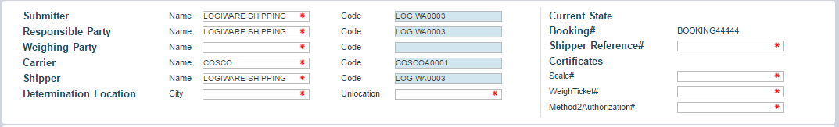

The matrix below shows which fields are required for each Submission Type:

|  |  |  |  |  |  |  |  |  |  |
| --- | --- | --- | --- | --- | --- | --- | --- | --- | --- |
| **Fields** | **Case 1** | **Case 2** | **Case 3** | **Case 4** | **Case 5** | **Case 6** | **Case 7** | **Case 8** | **Case 9** |
| **Submitter** | SHIPPER | FWDR | WEIGHING PARTY | TERMINAL | SHIPPER | SHIPPER | SHIPPER | SHIPPER | SHIPPER |
| **Responsible Party** | SHIPPER | SHIPPER |  | SHIPPER | SHIPPER | SHIPPER | SHIPPER | SHIPPER | SHIPPER |
| **Authorized Party** |  | FWDR |  | TERMINAL |  |  |  |  | Tom Jones |
| **Weighing Party** |  |  | WEIGHING PARTY | TERMINAL |  | CERTIFIED WEIGHING | CERTIFIED WEIGHING |  |  |
| **Carrier** | YES | YES |  | YES | YES | YES | YES |  |  |
| **Shipper** | YES |  |  | YES | YES | YES | YES | YES | YES |
| **Forwarder** |  | YES | YES |  |  |  |  |  |  |
| **Terminal** |  |  |  |  |  |  |  | YES | YES |
| **Booking Number** | YES | YES |  | YES | YES | YES | YES | YES | YES |
| **Submitter Reference** | YES | YES | YES | YES | YES | YES | YES | YES | YES |
| **Container Number** | YES | YES | YES | YES | YES | YES | YES | YES | YES |
| **Verified Gross Mass** | YES | YES | YES | YES | YES | YES | YES | YES | YES |
| **VerificationDetails** | YES | YES |  | YES | YES | YES | YES | YES | YES |
| **VGM Determination Date Time** | YES | YES | YES | YES | YES | YES | YES | YES | YES |
| **VGM Determination Location** |  |  |  | YES |  | YES | YES | YES | YES |
| **VGM Determination Method** |  |  | YES | YES |  | YES | YES | YES |  |
| **Certificates** |  |  | YES | YES |  |  | YES | YES |  |
| **Shippers Reference Number** |  |  |  |  | YES |  | YES |  |  |
| **Container Details** |  |  | YES | YES | YES | YES | YES |  |  |

## Entering Carrier notification email address

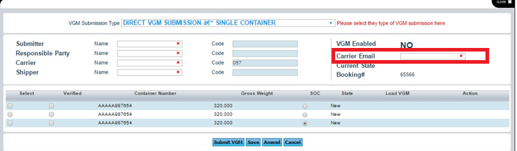

The above email address field will be populated based on the carrier set up as shown in the below image. User can also override the email address. Carrier will send the response to the entered email address along with the email address of user who submitted the VGM.

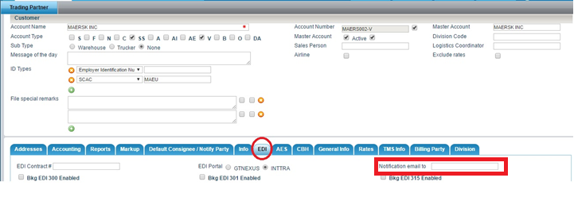

## Submitting the Container VGM record to the Carrier

④ Next, select the Container that is to be submitted to the Carrier by clicking on the Verified Checkbox and the Select Radio button.

* Select – Selects the Container to send the VGM EDI message.
* Verified – Must be checked before VGM EDI can be submitted for the Container signifying that the Gross Mass has been verified.
* SOC - If the Container is a Shipper Owned Container, then click on the SOC radio button.
* Load VGM - ?
*  - This button will display the XML code that will be transmitted to the Carrier.

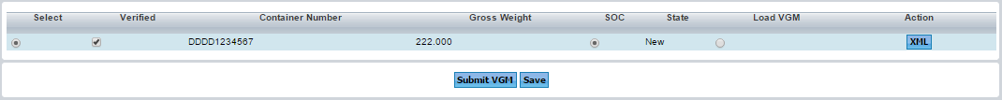

⑤ Press the  button to submit the Container VGM message to the Carrier.



NOTE: You will need to submit each Container separately to the Carrier, one at a time.

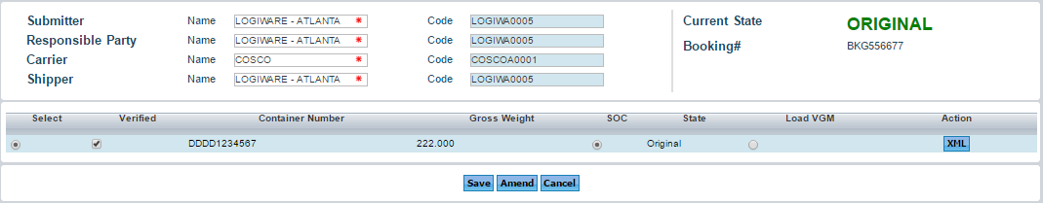⑥ Once the Container has been submitted the State of Container will change from NEW to ORIGINAL as shown below.

Also when that Container is selected again, the Button will change from  to . If you need to resend the VGM record for that Container, you will need to go into the CONTAINER TAB and change the Weight, then return to the VGM screen and press the  button to resubmit the new Weight.

